
KSIT Bangalore
DEPARTMENT OF COMPUTER SCIENCE AND ENGINEERING
ASSIGNMENT QUESTIONS
Academic Year | 2018-2019
Batch | 2015-2019
Year/Semester/section | 2018/V/ A & B
Subject Code-Title | 15CS54 – AUTOMATA THEORY AND COMPUTATIONAL INTELLIGENCE
Name of the Instructor | Mr. K Venkata Rao | Dept | CSE

Assignment No: 1 Total marks:20
Date of Issue:01-09-2018 Date of Submission:14-09-2014
Sl.No | Assignment Questions | K  Level | CO | Marks
 | Define the following terms:  a)Alphabet b) Power of an alphabet c) Language d) strings |  | CO1 | 2
 | Draw a DFA to accept strings of a’s and b’s having odd no. of a’s and even no. of b’s. |  | CO1 | 2
 | Obtain an NFA to accept strings of a’s and b’s ending with ‘ab’ or ba’. From this NFA Obtain an Equivalent DFA. |  | CO1 | 2
 | Convert the following ε-NFA to its equivalent DFA.  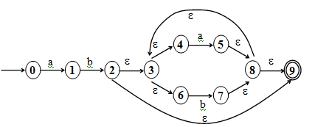 |  | CO1 | 2
 | Write differences between DFA, NFA and ε-NFA. |  | CO1 | 2
 | Define a regular expression. Find regular expression for the following languages on{ a, b }: i) L={a^{2n}b^{2m} | n ≥0 and m ≥0  ii)L={ w : |w | mod 3 = 0}, w ∈ { a, b }* |  | CO2 | 2
 | Give regular expressions for the following languages on ∑ = {a, b, c}  - all strings containing exactly one a  - all strings containing no more than three a’s  - all strings that contain at least one occurrence of each symbol in ∑ |  | CO2 | 2
 | Obtain a Regular expression for the language.  - L={a^{n}b^{m} | n+m is even}  - L={a^{n}b^{m} |m ≥ 1, n ≥ 1 and nm ≥0 } |  | CO2 | 2
 | Let M be the following DFSM. Use minDFSM to minimize M.  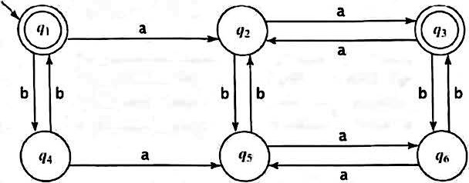 |  | CO4 | 2
 | Define distinguishable and indistinguishable states. Minimize the following DFA  0 1  A B A  B A C  C D B  *D D A  E D F  F G E  G F G  H G D  - Draw the table of distinguishable and indistinguishable states for the automata.  - Construct minimum state equivalent of Automata. |  | CO4 | 2

Course In charge Module Coordinator

HOD/CSE Chief Academic Coordinator

